PRESS RELEASE

Parbec Resource Estimate

Toronto – March 7, 2016 – Renforth Resources Inc. (CSE: RFR) (“Renforth” or the “Company”) Renforth is pleased to provide an initial resource statement prepared pursuant to NI 43-101 for the Parbec Property, located on the Cadillac Break in Malartic, Quebec as follows;

 | March 2016 Parbec Resource Estimate 0.5 g/t Au Cutoff
 | Indicated
ZONE | Tonnage (t) | Total Au (g) | Total Au (oz) | Grade g/t
Tuffs: Total | 263,230 | 952,317 | 33,592 | 3.62
 | Inferred
Tuffs: Total | 1,862,268 | 5,000,236 | 176,378 | 2.69
Felsites: Total | 1,430,441 | 2,220,844 | 78,338 | 1.55
Porphyries: Total | 3,964,162 | 7,353,620 | 259,392 | 1.86
 | Totals
Parbec Total Indicated | 263,230 | 952,317 | 33,592 | 3.62
Parbec Total Inferred | 7,256,872 | 14,574,700 | 514,108 | 2.01
- Mineral resources which are not mineral reserves do not have demonstrated economic viability. The estimate of mineral resources may be materially affected by environmental, permitting, legal, title, taxation, socio-political, marketing, or other relevant issues.
- The quantity and grade of reported Inferred resources in this estimation are uncertain in nature and there has been insufficient exploration to define these Inferred resources as an Indicated or Measured Mineral Resource and it is uncertain if further exploration will result in upgrading them to an Indicated or Measured mineral resource category.
- The mineral resources in this report were estimated using the Canadian Institute of Mining, Metallurgy and Petroleum (CIM), Standards on Mineral Resources and Reserves, Definitions and Guidelines prepared by the CIM Standing Committee on Reserve Definitions and adopted by CIM Council.
- A cut-off value of 0.5 g/t Au was used in the preparation of this resource

“We could not be more pleased with our release of an initial resource at Parbec, we look forward to our future exploration goals which include dewatering the ramp, as well as drill testing targets which detailed modelling has identified. Continuity of mineralization is demonstrated along approximately 75% of the Cadillac Break on the property but we have not fully defined the quantity of gold within that area. We look forward to future exploration and drilling, funding permitting, adding more value to Parbec.” states Nicole Brewster, President and CEO of Renforth.

Parbec Mineralization

There are three types of mineralization identified at Parbec and occurring within the resource area;
- along the northern contact of the break lie the 'Tuffs'. These are essentially biotite altered sericitized volcanics which include units with some inherent tuffaceous textures. Silicified portions can carry better grades. The tuffs have been traced by drill intercepts across the entire property.
- there is a significant 50-100m wide swath within the Cadillac Break and located south of the Tuffs consisting of porphyries and diorite intrusions. A number of parallel mineralized systems consisting of brecciation and fracturing have been identified along the contacts and within these intrusives which can achieve widths of more than 20 m in certain areas.
- Felsites are generally located within the sediments south of the Cadillac Break and are continuous across the property. They are often fractured with varying levels of silicification and alteration. Several parallel mineralized zones are not well identified as most historic holes targeting the porphyries and tuffs were collared to the north of the felsites.

Current Geological Interpretation

Renforth has spent some time compiling a geological interpretation of the mineralization at Parbec. Physical maps and digital depiction of the data will be available at Renforth’s booth (221B) at the Prospectors and Developers Assoc. of Canada’s annual convention March 8th and 9th. An image of the geological compilation surface plan is presented below;

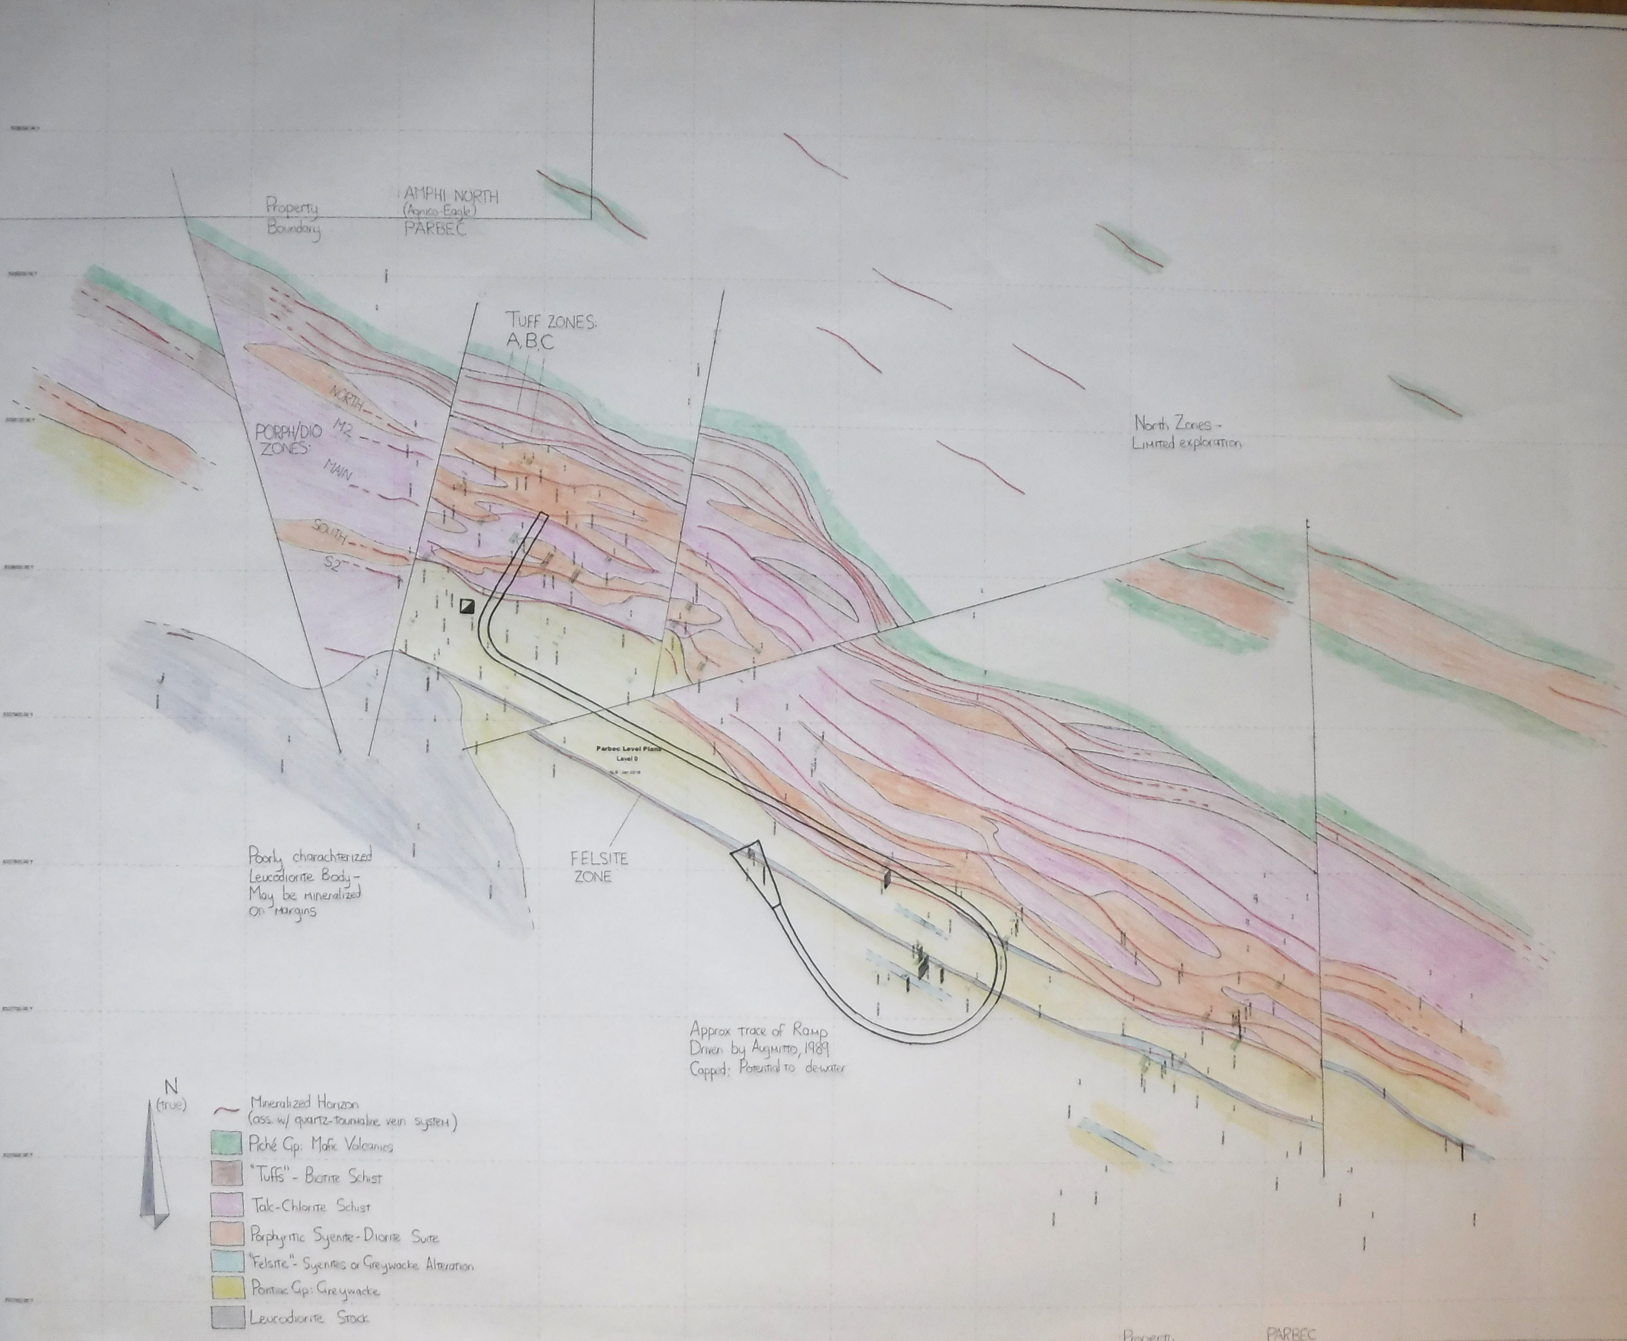

Future Exploration at Parbec

Several areas exist to be targeted in future exploration at Parbec, as follows;

- Drilling from surface within the deposit as modeled, to depth and along strike – the process of detailed modeling that resulted in this initial resource calculation also highlighted “gaps” within the model. These gaps can be targeted with surface drilling and if successful would positively impact the resource. Within the outlined resource there are deeper gold intersections, gaps occur between these and the bulk of the resource (100% of the indicated and approximately 73% of the inferred resource is located within 200m of surface). The vertical gaps are priority drill targets. Lastly, the structure is open along strike and. represents a prospective target along its length.
- Dewatering the ramp – the 580 m ramp at Parbec ends at 100 m depth, about 30m south of the Tuff horizon in the Camp Zone which it was targeting. This ramp, once dewatered, would provide access to sample the ramp, including the felsite zone it was collared in and provide underground drilling stations to investigate the main mineralized zones. Additionally, the ramp could be extended along strike to allow additional drilling at depth and along strike as well as access for bulk sampling of the mineralized zones.
- Structural exploration – the resource modeling process has identified several areas of elevated gold values occurring in proximity to fault junctions. Some of the best deeper intersections at Parbec occur in this setting. Drilling above and below those intersections to increase known high grade areas is planned .
- A large intrusive diorite stock, historically identified and verified in the field by Renforth is located in the SW portion of the property, on the south side of the Break. The marginal areas of this intrusive have been found to host elevated gold values in drill intercepts outside of the area of the current resource. An intrusive can be a heat engine for the emplacement of gold as well as provide a prospective environment for mineralization in the fracturing that occurs along the intrusive’s margins.
- Northern exploration targets – as detailed in previous press releases additional targets exist to the north of the Cadillac Break.

Brian H. Newton P.Geo, a “Qualified Person” pursuant to NI 43-101, is responsible for the preparation of this resource statement and has reviewed and approved the technical disclosure within this press release. A complete Technical Report will be posted on the Company’s website and on SEDAR with 45 days of this news release.

ABOUT RENFORTH
Renforth Resources Inc. is a Toronto-based gold exploration company with interests in two of Canada’s gold exploration camps. In the Cadillac-Malartic Gold Camp the Company holds the New Alger project, with an inferred resource of 237,000 ounces of gold above a depth of 200 metres contained in 3,505,000 tonnes with a grade of 2.1g/t Au using a cut-off of 0.75 g/t Au (see press release July 17, 2014) as calculated by Brian H. Newton P.Geo and Philip Burt P.Geo, which is located on the Cadillac Break outside of Cadillac, Quebec and an option to purchase 100% of the Parbec Property from Globex Mining Enterprises Inc. (GMX-TSE), a historically identified gold occurrence with more than 100 drillholes completed and a ramp into the mineralization in place located outside of Malartic, Quebec, contiguous to the Canadian Malartic open pit mine. In Ontario the Company has the right to earn a 55% interest in the Nixon-Bartleman project, located on the Porcupine-Destor fault in the West Timmins Mining area, another historic gold occurrence with a couple of old shallow pits onsite and a history of past drilling which has not yet defined the gold occurrence.
For further information please contact:

Renforth Resources Inc.

Nicole Brewster

President and Chief Executive Officer
T: (416) 368.5049 C:416-818-1393
E: nicole@renforthresources.com
#304 – 65 Front St. E, Toronto, ON M5E 1B5

No securities regulatory authority has approved or disapproved of the contents of this news release.

Forward Looking Statements

This news release contains forward-looking statements and information under applicable securities laws. All statements, other than statements of historical fact, are forward looking. Forward-looking statements are frequently identified by such words as ‘may’, ‘will’, ‘plan’, ‘expect’, ‘believe’, ‘anticipate’, ‘estimate’, ‘intend’ and similar words referring to future events and results. Such statements and information are based on the current opinions and expectations of management. All forward-looking information is inherently uncertain and subject to a variety of assumptions, risks and uncertainties, including the speculative nature of mineral exploration and development, fluctuating commodity prices, the risks of obtaining necessary approvals, licenses and permits and the availability of financing, as described in more detail in the Company’s securities filings available at www.sedar.com. Actual events or results may differ materially from those projected in the forward-looking statements and the reader is cautioned against placing undue reliance thereon. Forward-looking information speaks only as of the date on which it is provided and the Company assumes no obligation to revise or update these forward-looking statements except as required by applicable law.

